Wetland Workgroup Meeting
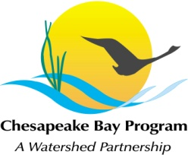
National Park Service
Small Conference Room
410 Severn Ave (Suite 314)
Annapolis, MD 21403

Tuesday, December 13th, 2016
1:00 - 3:00PM

Conference Line: 515-739-1262 Code: 140386#
Adobe Connect: https://epawebconferencing.acms.com/wetlandworkgroup
(Note: Enter as Guest with your name and affiliation)

1:00 Introductions from Wetland Workgroup members / Review of goals and agenda
- Input from Wetland Workgroup – At least one cool wetland update from your state or organization.
1:10 Landowner Outreach Committee Update – Kyle Runion
1:20 Updates on related efforts – Erin McLaughlin
- Habitat GIT Meeting, Coastal Resiliency, cross GIT BMP ranking)
2:00 Wetland Expert Panel FINAL REPORT – The Wetland Expert Panel will present the Final Report. Several members of the Expert Panel will be attending in person and by phone to answer questions. Comments received through the December 7th deadline will be reviewed.
- Input from Wetland Workgroup – The Wetland Workgroup is tasked with approving the WEP Final Report. We ask that all Wetland Workgroup members make an effort to attend the meeting in person or remotely to hear this presentation and offer input.
3:00 Adjourn & request speakers for 2017
Tentative 2017 Meeting dates
Jan 26
March 16
May 18
July 20
Sept 14
Nov 16
Each of these meetings will take place in CBP Conference Room 305, conference line: 866-299-3188, code: 267-985-6222.

