Wetland Workgroup Meeting
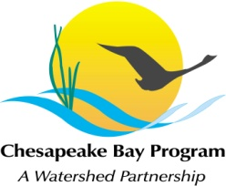
Chesapeake Bay Program Office
Joe Macknis Memorial Conference Room (Fish Shack)

Thursday, March 17th, 2016
1:00-3:00PM

Conference Line: 866-299-3188 Code: 410-267-5731
Adobe Connect: https://epawebconferencing.acms.com/wetlandworkgroup
(Note: Enter as Guest with your name and affiliation)

1:00 Introductions and updates from Wetland Workgroup members / Review of goals and agenda
- Input from Wetland Workgroup – At least one cool wetland update from your state or organization.
1:15 Delaware Wetland Conference Social Marketing Overview and Recommendations
- Input from Wetland Workgroup – discussion on need and content for cross-training
1:25 STAC Enhancing Capacity Workshop Overview and Recommendations

1:30 Wetland Expert Panel Update
- Input from Wetland Workgroup – questions concerning Expert Panel process and next steps
1:45 Wetland Workgroup 2-year Workplan Comments (Public Comment period ended March 8th)

2:15 Guest Presentation: “Floodplain Restoration along Channelized Streams on the Coastal Plain” Presented by Steve Strano, NRCS Maryland State Biologist and Amy Jacobs, The Nature Conservancy
3:00 Adjourn

