Wetland Workgroup Meeting
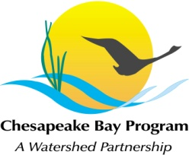
Maryland DNR, Tawes Building
Conference Room C-1A
580 Taylor Ave.
Annapolis, MD 21401

Thursday, September 15th, 2016
1:00 - 3:00PM

Conference Line: 866-299-3188 Code: 267-985-6222
Adobe Connect: https://epawebconferencing.acms.com/wetlandworkgroup
(Note: Enter as Guest with your name and affiliation)

1:00 Introductions from Wetland Workgroup members / Review of goals and agenda
- Input from Wetland Workgroup – At least one cool wetland update from your state or organization.
- Final 2015 restored acreage on agricultural lands check
1:10 Quick Updates
- Cross-Goal Climate Resiliency Analysis project – Erin McLaughlin
- GIT Funding Approved for proposal: Increasing landowner participation in wetland programs through improved information access and program staff cross-training
  - Next steps – Amy Jacobs
1:20 Pennsylvania Wetland Mapping Update – Jill Whitcomb
1:30 Wetland Expert Panel Preliminary FINAL REPORT – The Wetland Expert Panel will present the Preliminary Final Report. Several members of the Expert Panel will be attending in person and by phone to answer questions.
- Input from Wetland Workgroup – The Wetland Workgroup is tasked with approving the WEP Final Report. We ask that all Wetland Workgroup members make an effort to attend the meeting in person or remotely to hear this presentation and offer input.
3:00 Adjourn

