Wetland Workgroup Meeting
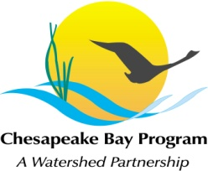
Chesapeake Bay Program Office
Conference Room 305A

Thursday, June 28th, 2016
1:00-3:00PM

Conference Line: 866-299-3188 Code: 267-5715
Adobe Connect: https://epawebconferencing.acms.com/wetlandworkgroup
(Note: Enter as Guest with your name and affiliation)

1:00 Introductions and updates from Wetland Workgroup members / Review of goals and agenda
- Input from Wetland Workgroup – At least one cool wetland update from your state or organization.
1:10 GIT Funding Update (Erin McLaughlin)

1:15 Update on the Wetland Expert Panel (Erin McLaughlin)

1:30 Climate Resiliency Analysis and Decision Making Matrix Project update (Erin McLaughlin)

1:40 Landowner Survey Results – Key Findings and Discussion of where to go next (Kyle Runion)

2:15 Guest Presentation: “Optimizing design of non-tidal wetland restoration/ creation to improve water quality function” Presented by Greg Noe, Senior Scientist with USGS

3:00 Adjourn

