Wetland Workgroup Meeting
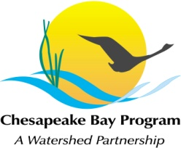
Chesapeake Bay Program Office
Fish Shack, Green Building

Thursday, March 19, 2015
1:00-3:00PM

Conference Line: 866-299-3188 Code: 410-267-5731
Adobe Connect: https://epa.connectsolutions.com/wetlandworkgroup/ (Note: Enter as Guest with your name and affiliation)

1:00 Welcome and Introductions
1:10 Management Strategy Update and Needs
1:25 Tracking and Reporting Update
1:40 Targeting Restoration Discussion and Identification of Criteria
2:10 Expert Panel and Chesapeake Bay Program Funding Updates
2:20 Guest Presentation: Chesapeake Bay Habitat Tool – A resource for prioritizing locations for tidal wetland restoration (Michelle Canick, The Nature Conservancy)
3:00 Concluding Remarks/Updates

