Wetland Workgroup Meeting
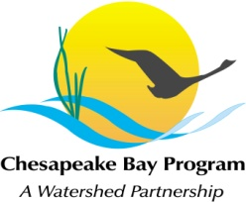
Chesapeake Bay Program Office
Conference Room 305A

Thursday, July 16, 2015
1:00-3:00PM

Conference Line: 866-299-3188 Code: 410-267-5731
Adobe Connect: https://epa.connectsolutions.com/wetlandworkgroup/ (Note: Enter as Guest with your name and affiliation)

1:00 Welcome and Introductions
1:10 Tracking and Reporting Update
1:20 Refresher – how to report wetland acres
1:30 Targeting Update
1:40 Wetland Expert Panel Update
1:50 Verification
2:00 Guest Presentation: Non-tidal Wetland Restoration on Delmarva – Successful Projects and Lessons Learned (Rich Mason, USFWS – Chesapeake Bay Field Office)
This presentation will include a brief overview of wetland restoration and enhancement projects on Maryland's Eastern Shore. The success and pitfalls of different restoration techniques will be shared, as well as wildlife and water quality benefits. New experimental techniques will be presented as a potential way to improve hydrology to restored and natural wetlands, streams, riparian habitats, and ultimately Chesapeake Bay. Participant discussion will be important after the formal part of the presentation.
2:55 September In-Person Meeting (near Easton, MD) and Concluding Remarks

