Wetland Workgroup Meeting
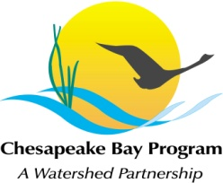
Chesapeake Bay Program
Conference Room 305
410 Severn Ave
Annapolis, MD 21403

Thursday, July 20th, 2017
1:00 - 3:00PM

Conference Line: 866-299-3188 Code: 267-985-6222
Adobe Connect: https://epawebconferencing.acms.com/wetlandworkgroup
(Note: Enter as Guest with your name and affiliation)

1:00 Introductions from Wetland Workgroup members / Review of goals and agenda
- Action: At least one cool wetland update from your state or organization.

1:15 Developing a Wetland Outreach Strategy with Landowners in Mind – Brittany Haywood, DNREC

2:00 Wetland Expert Panel update - Jeremy Hanson, VT

2:20 2017 CBP GIT Funding Discussion – ideas for projects should be communicated to workgroup chairs before the meeting.

2:50 Request speakers for future meetings

3:00 Adjourn Workgroup Meeting

3:00 Wetland Outreach Committee Meeting with GIT Funding Contractor (open to workgroup members)

4:00 Adjourn committee meeting

Tentative 2017 Meeting dates
Sept 14
Nov 16
Each of these meetings will take place from 1-3pm in CBP Conference Room 305, conference line: 866-299-3188, code: 267-985-6222.

