Wetland Workgroup – Outreach Subcommittee Meeting
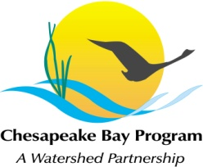
Chesapeake Bay Program
Conference Room 303
410 Severn Ave
Annapolis, MD 21403

Wednesday, October 4, 2017
11:15am - 12:15PM

Conference Line: (872) 240-3412Code: 555-267-829
GoToMeeting: https://global.gotomeeting.com/join/555267829

11:15 Wetland Landowner and Service Provide Interview Presentation – Paula Jasinski
- Overview of Project and Timeline
- Interview findings and Messages
- Comparative Analysis Review
- Discussion of Next Steps

12:15 Adjourn

Next Meeting date:
November 14, 2017 – 9am-12pm – CBPO Fish Shack: Design Sprint

