Riparian Forest Buffer Quarterly Progress Meeting

Outcome: Riparian Forest Buffer

Continually increase the capacity of forest buffers to provide water quality and habitat benefits throughout the watershed. Restore 900 miles per year of riparian forest buffer and conserve existing buffers until at least 70 percent of riparian areas throughout the watershed are forested.

Lead and Supporting Goal Implementation Teams (GITs):

Water Quality GIT; supported by Maintain Healthy Watersheds and Vital Habitat GITs

Participating Partners:
- State of Delaware
- State of Maryland
- State of New York
- Commonwealth of Pennsylvania
- Commonwealth of Virginia
- State of West Virginia
- Chesapeake Bay Commission
- Farm Service Agency (U.S. Department of Agriculture)
- National Park Service
- Natural Resources Conservation Service (U.S. Department of Agriculture)
- U.S. Army Corps of Engineers
- U.S. Department of Defense
- U.S. Environmental Protection Agency
- U.S. Fish and Wildlife Service
- U.S. Forest Service
- U.S. Geological Survey
- Alliance for the Chesapeake Bay
- Baltimore Greenspace
- Cacapon Institute
- Casey Trees
- Chesapeake Bay Foundation
- Delaware Center for Horticulture
- Ducks Unlimited
- Maryland Farm Bureau Federation
- The Nature Conservancy
- Parks and People Foundation
- Pennsylvania Conservation Districts
- Pheasants Forever
- Potomac Conservancy
- Smithsonian Institution
- Stroud Water Research Center
- Tree Baltimore
- Trout Unlimited
- Virginia Agribusiness Council
- Virginia Cattlemen’s Association
- Virginia Dairymen’s Association
- Virginia Farm Bureau
- Virginia Grain Producers

Progress:
We are not on track to meet our goal.

Figure 1 shows progress of restoring new RFB in Bay as reported in Bay Barometer. Note that 2016 90% of miles came from Penn State survey. Otherwise, restoration rate was similar to 2015.

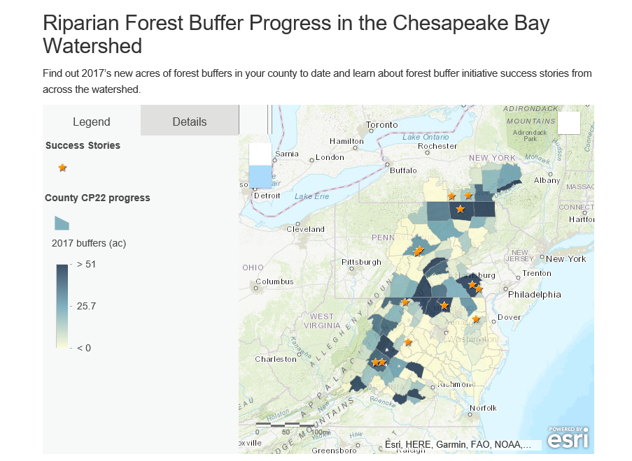

Figure 2 shows certain counties with more progress (those shaded dark blue) neighboring counties with little progress (as shown on www.chesapeakeforestbuffers.net)

What are our assumptions?

- What original assumptions did we make in our Management Strategy that we felt were important to our success?
  - What “Factors Influencing Success” were originally identified in your Management Strategy?
- Fluctuation in commodity crop values
- Inter-generational transfer of agricultural lands
- Loss of agricultural lands
- Lack of congressional authorization of a new Farm Bill, which caused Conservation Reserve Program to experience extensive delays in 2013 and 2014
- Federal/state/local leadership place insufficient emphasis on RFB as a priority practice and allow less beneficial practices to successfully compete for riparian space
- Technical assistance is insufficient
- Lack of interagency coordination and staff training at all levels of government
- Lackluster incentives, and incentives that are not strategic and do not leverage resources wisely
- Federal funds go unused, sometimes for lack of a 20% match
- Federal programs lack the flexibility states and landowners need
- Outreach to landowners with riparian areas needs to stress the importance of RFB, new information, and improved incentives for enrollment, re-enrollment, and permanent protection
- Better understanding of why only 53% of RFB acres are re-enrolling upon expiration of first 15-year contract –work to increase re-enrollment or ease buffer
- Lack of information available to landowners and technical assistance providers
- Unsatisfactory survival of buffer plantings and maintenance issues primarily due to excess deer and vole browse and competing vegetation
- Complicated cost-share program application and implementation process accompanied by unclear communication
- Lack of targeting riparian forest buffers to where they would do the most good
- Lack of focus on permanent protection of riparian forest buffers; they are often lost when agricultural lands are converted to development and small, linear easements are difficult to manage.

  - What programmatic gaps that fail to address those factors did you originally identify in your Management Strategy?
- Inconsistent availability of the Conservation Reserve Enhancement Program (CREP) hinders landowner outreach. These interruptions increase skepticism among landowners and program staff about CREP’s viability. It is also difficult to talk about program benefits with landowners when the program is not currently open.
- Inconsistent leadership at the local level that recognizes that riparian forest buffers are a priority practice. Counties that prioritize riparian forest buffers have more success than those that do not.
- Environmental Quality Incentives Program does not leverage the implementation of riparian forest buffers through the CREP in application rankings. This limits the ability to leverage funding and provide a substantial incentive for riparian forest buffers.
- State FSA and NRCS goals do not include state watershed implementation targets. The lack of common goals disconnects state and federal priorities.
- Lack of coordination with other federal, state, and private conservation funding programs on how investments can be leveraged.
- State and local FSA and NRCS offices lack outcome-based performance measures to assess success (e.g. miles and acres of riparian forest buffer established).
- Program communication is too complicated and hinders landowner enrollment.
- Lack of training for technical service providers, land trusts and other partners on the importance of riparian forest buffers, assessment of the costs and benefits of implementing forest buffers for landowners, and marketing strategies.
- Application process needs to be streamlined especially for offices where partners are not co-located. Agencies that are working together with a streamlined process have more success than those that do not.
- Landowners do not always have a point of contact on whom they can rely for guidance for the life of the contract
- Successful establishment of a riparian forest buffer requires long-term maintenance. Fields of leaning or downed tree-tubes and other signs of failure discourage landowners from enrolling in programs.
- Incentives for establishment are inadequate and need to begin before planting and occur for at least five years.
- Given limited incentives, landowners have difficulty dealing with maintenance issues (e.g. invasive species, tree shelters, loss due to flooding, etc.) the first few years after planting.
- A lack of technical assistance for riparian forest buffers and related practices can create a bottleneck for implementation.
- There are limited funds made available for technical assistance
- Riparian forest buffer easement programs are not active in most Chesapeake Bay jurisdictions.
- Many Conservation Reserve Enhancement Program contracts are set to expire in the next few years, and a lack of outreach and technical assistance and changing crop prices could lead to a decline in the area of riparian forest buffers.
- Grass buffer contracts that have naturally regenerated to forest may be unable to reenroll as a forest buffer.

  - What were the “Management Approaches” you chose to include in your Management Strategy and Two-Year Work Plan in order to address those gaps?
- Leadership
- Programmatic Barriers
- Technical Assistance
- New Enrollment
- Establishment/Maintenance
- Re-enrollment
- Targeting
- Easement Programs
- Non-ag lands

Are we doing what we said we would do?
- Are you on track to achieve your Outcome by the identified date?
  - What is your target? What does this target represent?
Restore 900 miles per year of riparian forest buffer a year and conserve existing buffers until at least 70 percent of riparian areas throughout the watershed are forested.
There is no deadline for this goal; this is an annual goal. Note: 70 percent forested riparian area is a minimum goal. New, high-resolution data indicate that we are closer to 70 percent than we originally thought. This should not be a deterrent to getting riparian areas forested as they are clearly still needed and the long-term target should be revised to reflect a “ceiling” rather than a “floor”.
  - What actual progress has been made thus far?
Average new acres of forest buffers in recent years is about 60.
There are still about 1.4 million acres of riparian in crop, pasture, or turf in the watershed. See Figure 1.
  - What could explain any existing gap(s) between your actual progress and anticipated trajectory?
        - Lack of sustained leadership support
        - Not having fully-functional teams at the local level to delivery CREP and other programs
- Staff turnover and a low numbers of technical service providers (TSPs)
- Competing programs for limited riparian area
- Many key people/positions (from leadership to local level) still don’t get it
- Slow pace/need to greatly accelerate efforts
- No concerted buffer program for non-ag lands

- Which of your management actions have been the most critical to your progress thus far? Why? Indicate which influencing factors these actions were meant to manage.
Additional field positions added with assistance of FSA
Outreach
Incentive funding

- Which of your management actions will be the most critical to your progress in the future? Why? What barriers must be removed—and how, and by whom—to allow these actions to be taken? Indicate which influencing factors these actions will be meant to manage.
Improved leadership and technical assistance actions
Focus on implementation

Are our actions having the expected effect?
- What scientific, fiscal, or policy-related developments or lessons learned (if any) have changed your logic or assumptions (e.g., your recommended measure of progress; the factors you believe influence your ability to succeed; or the management actions you recommend taking) about your Outcome?

How should we adapt?
- What (if anything) would you recommend changing about your management approach at this time? Will these changes lead you to add, edit, or remove content in your Work Plan? Explain.
There needs to be more focus on improved implementation by creating fully-functioning local teams, integrating RFB upfront as part of whole farm planning, increasing TSPs through SWCDs and trusted farm consultants, provide comprehensive services to farmers, and increasing conservation of RFBs.
We need to elevate buffer needs through policy and leadership by having top water quality personnel work with RFB lead in each state, finding stable funding and staffing, developing state programs to put RFBs on non-ag lands, revisiting State Task Force Reports, meeting regularly with State Con, and having state CREP programs and policies reflect WIP Phase 3 needs.

- What opportunities exist to collaborate across GITs? Can we target conservation or restoration work to yield co-benefits that would address multiple factors or support multiple actions across Outcomes?
Could work with the Healthy Watersheds GIT on overlapping buffer concerns, the Habitat GIT (esp. wetlands and brook trout) on multifunctional buffers, the Climate WG on use of buffers for climate resiliency and mitigation, and the Ag WG and Water Quality GIT on whole farm planning.

- What is needed from the Management Board to continue or accelerate your progress? Multiple requests for action, support or assistance from the Management Board should be prioritized, where possible, and all requests should be “traceable” to the factors influencing progress toward your Outcome. Because a limited number of agencies and organizations are represented in the Management Board’s membership, we recommend naming those agencies and/or organizations that may play a key role in fulfilling your request for action, support, or assistance, in order to guide the Management Board in its work to contact, consult, or coordinate with partners.
  - RFBs need to be recognized as a fundamental water quality and agriculture practice and RFBs should be integrated and incorporated upfront as part of whole farm planning.
    - More involvement from NRCS to do this and wholesale increase of TSPs, e.g., major effort to train SWCDs and other partners, to get fully functioning buffer team in every county (may need to change job title/description)
  - State water quality co-lead buffer effort at each state along with technical lead
  - Stable and consistent funding for RFB programs and to keep trained staff
  - Non-ag RFB programs using state funding like 319 and SRF funds
  - CREP programs should reflect buffer goals of Phase 3 WIPs
  - Verification and RFB lifespan in NEIEN should align with re-enrollment (from 10 years to 15 years)

